The talisman is an attractive opal that you can place anywhere on the desktop

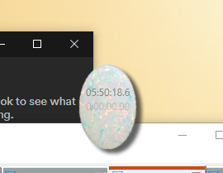

Click here to view settings, current timers, and more

Convenient stopwatch

Time until next appointment

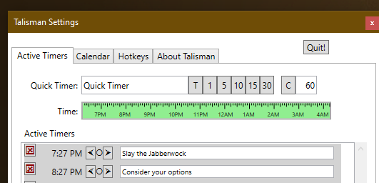

One-click timer setting   
by minutes from now   
or time of day

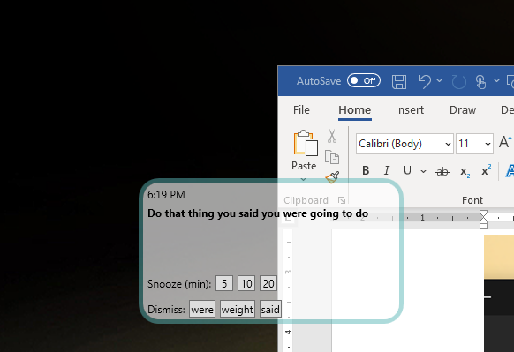

Only the button with the word that is not in the title will dismiss the alert!

Animated floating alert to grab your attention